1.The introduction of UAV(quadcopter)
Multi-rotor aircraft is one of flying robots or unmanned air vehicles(UAVs),also know as drones.In the past decade,the Multi-rotor aircraft has received great attention due to the use for both civilian and military.Nowadays, researchers designed and fabricated different types of multi-rotor aircrafts ranging from one to twelve motors. Among the Multi-rotor aircrafts, the quad-copters is the best known drones.
In fact, the quadcopters have been widely used in many kinds of industries,some of the most common commercial applications and uses for quadcopters are:
- Aerial Photography & Videography
- Real estate photography
- Mapping & Surveying
- Asset Inspection
- Payload carrying
- Agriculture
- Bird Control
- Crop spraying
- Crop monitoring
- Multispectral/thermal/NIR cameras
- Live streaming events
- Roof inspections
- Emergency Response
- Search and Rescue
- Marine Rescue
- Disaster zone mapping
- Disaster Relief
- Forenzics
- Mining
- Firefighting
- Monitoring Poachers
- Insurance
- Aviation
- Meterology
- Product Delivery
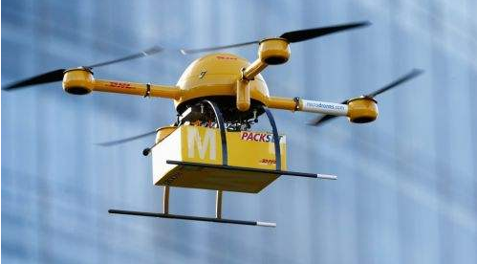
Cargo delivery

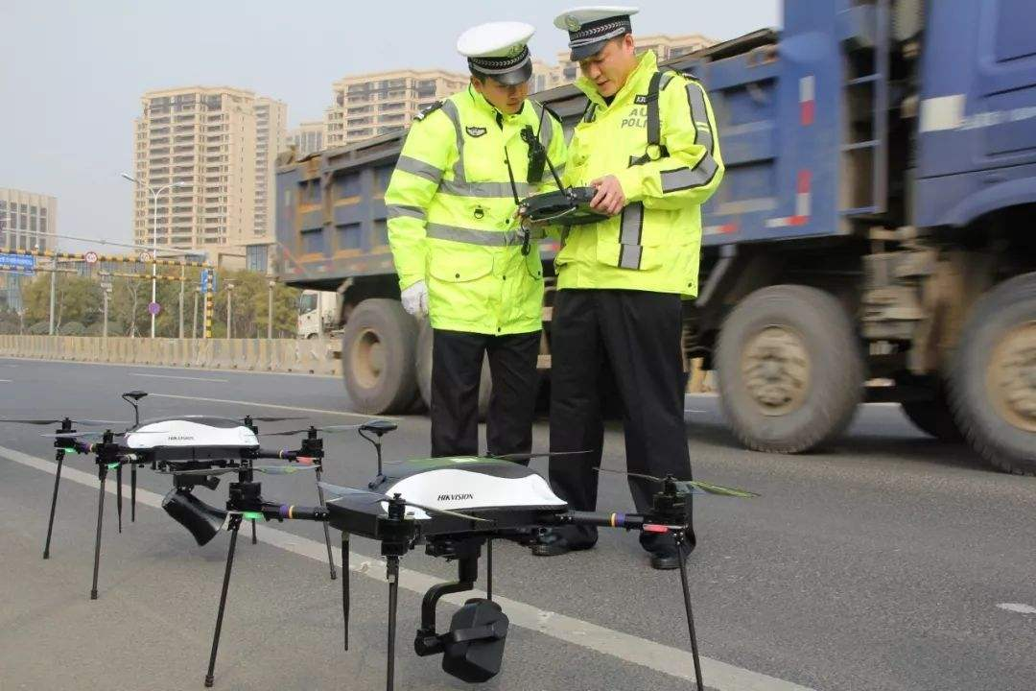
Traffic illegal monitoring
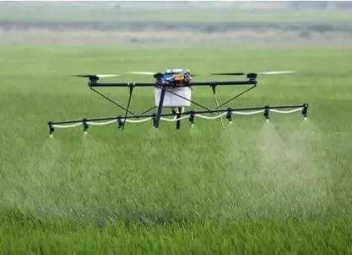
Crop spraying
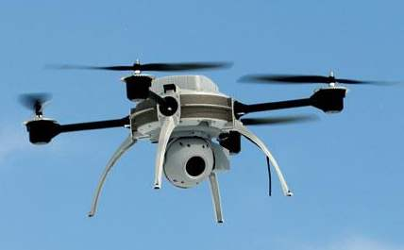
Aerial Photography & Videography
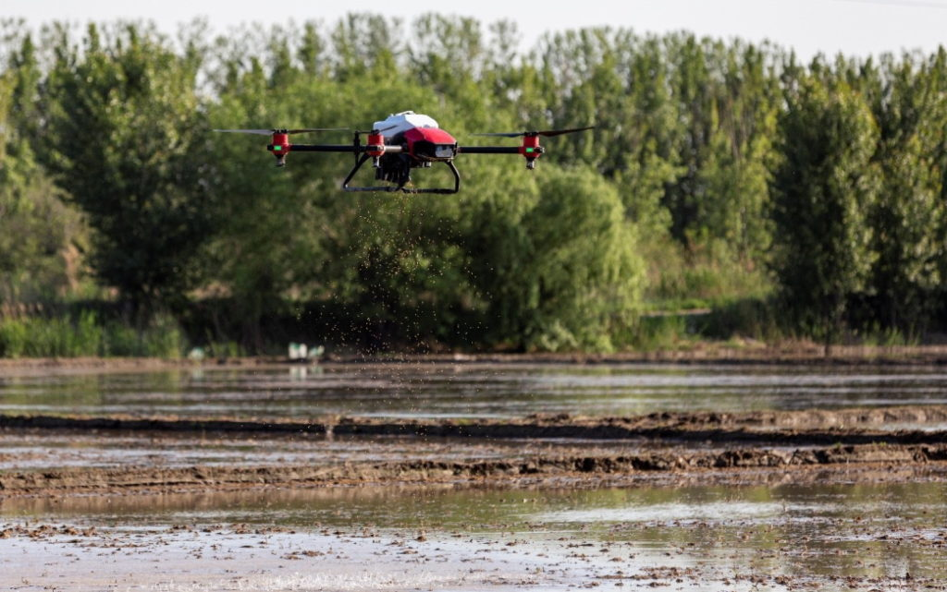
Rice seeding
In addition,the flying robot manufacturer can also provide systems to your specific requirements.It turns out that quadcopters are changing our lives,It is no doubt that the quadcopters will be part of our lives in the near future.

The composition of quadcopter
The basic structure of quadcopter is generally composed of airframe, power system and flight control system and so on.See the figure below:
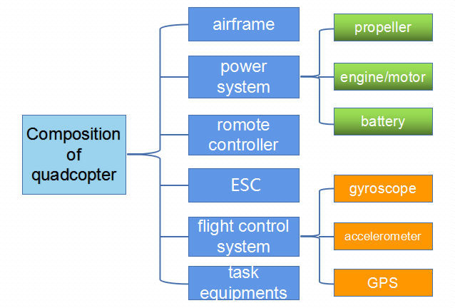
- Airframe.It is the fuselage of multi-rotor UAV, the installation foundation of other units, and plays a bearing role.The materials of the frame are plastic, glass fiber, carbon fiber, etc.Carbon fiber is used most due to its light weight and high strength.
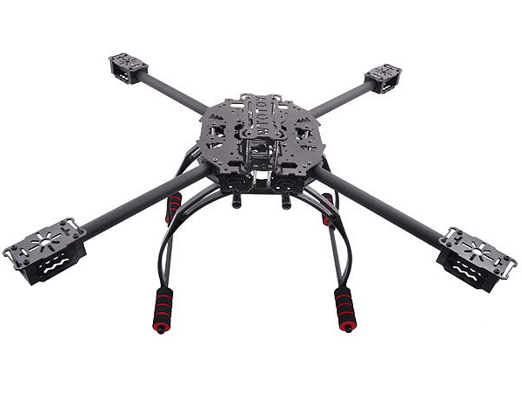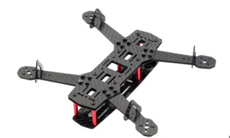
Axis distance is the most important data index of the frame, which refers to the distance between the two motors or the center of the blade of the diagonal line in mm ( mm ).
Four-axis 250 : represents the distance of the diagonal motor center is
250 mm of the quadcopter.
2)power system.The system that provides power for UAV flight. At present, the power system of multi rotor UAV is generally electric system, which is generally composed of battery, motor and propeller.
Propeller:Rotating produces tension or thrust to enable UAVs to complete flight activities.According to the different material, propeller is generally
divided into wood propeller,plastic propeller and carbon fiber propeller.

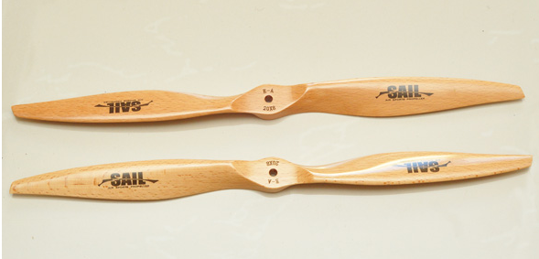
Wood propeller
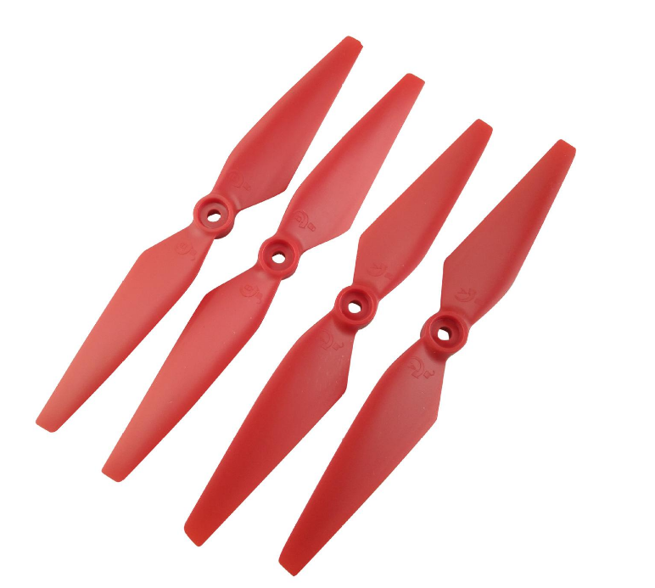
Plastic propeller
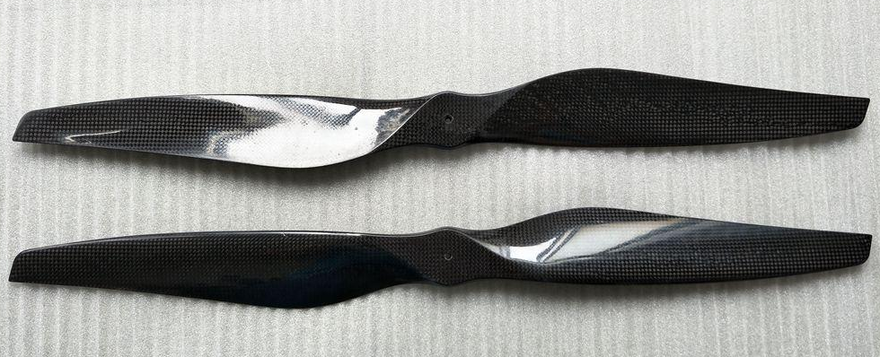
carbon fiber propeller
The multi-rotor aircraft is similar to the helicopter,the difference is multi-rotor’s motion controlled by changing the speed of different propellers and the helicopter controlled by changing the angle of attack of the propellers.
The size of propeller is usually represented by a number in the shape of "XXXX". The first two digits represent the diameter of the propeller, and the last two digits represent the pitch of the propeller, both in inches. The pitch is the distance of the plane of rotation of the blade for one revolution.
A propeller is characterized by two sizes: the diameter and the pitch. The diameter is the tip-to-tip distance of the 2 blades and constitutes the work area of the propeller It corresponds to the diameter of the disc that circumscribes the propeller. The pitch is defifined as the distance that the propeller travels in ideal conditions during a complete rotation. The pitch represents the height of the air column that will be moved during the complete rotation. The pitch is the incidence of the wing profifile or the inclination of the propeller with respect to the support pin
The typical propulsion unit of multirotor UAV consists of a brushless direct
current electric motor (BLDC), the propeller and the ESC - electronic speed controller.

Motor.The rotation of the motor drives the blade to make the UAV produce lift and thrust. By controlling the speed of the motor, the UAV can complete various flight states.
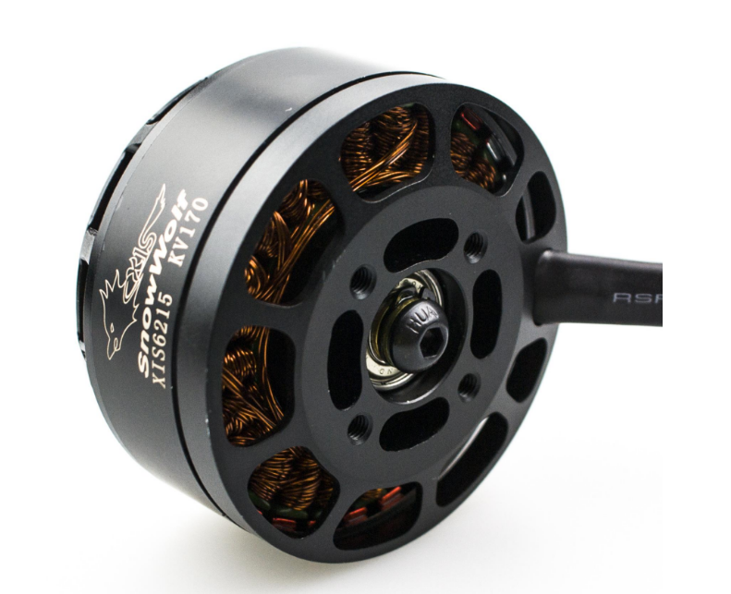
motor
Battery.It mainly provides energy for UAVs, including Ni Cd, Ni MH, Li ion and Li polymer batteries.Considering the weight and efficiency of batteries, most UAVs use lithium polymer batteries.At present, the biggest disadvantage of UAV is its endurance. Most quadcopters can only fly for about half an hour.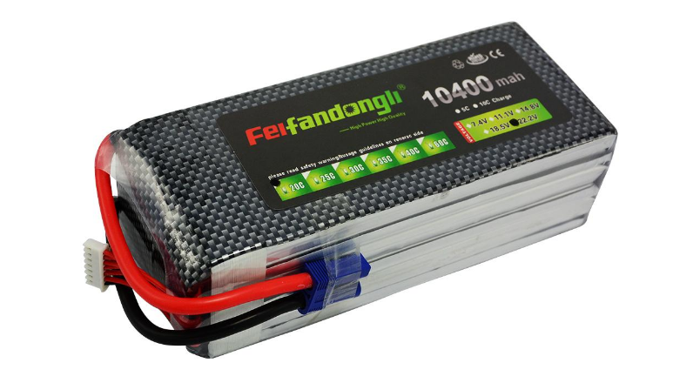
battery
3)Remote controller.used to control the flight and perform the corresponding tasks.There is a receiver connected with the flight control to receive the signal from the remote control.
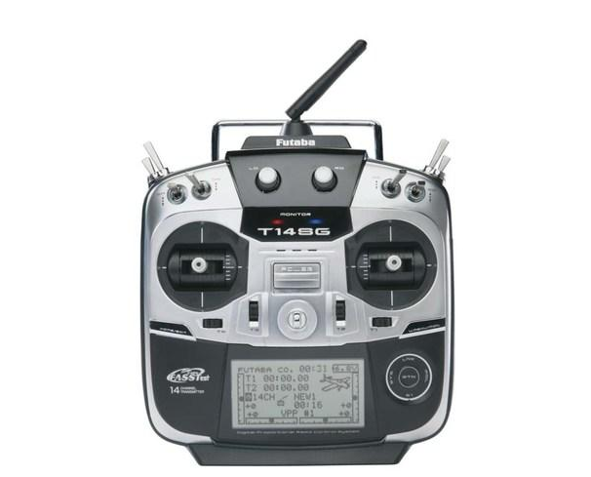
Remote controller
- Electronic Speed Controller(ESC).Its main function is to control the speed of the motor.Usually,a circuit module is also set in the ESC to convert the output voltage of 12V battery to 5V to supply power for the flight control system and remote control receiver.Also,some through a separate module called BEC(Battery Elimination Circuit )to complete this function to power the flight control system and remote control receiver.
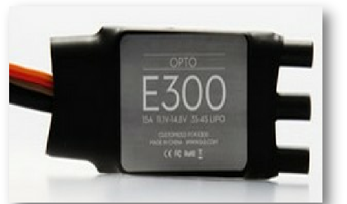
ESC
Both ends of the ESC are wired, one end is two(usually one red and one black) while other end is three(usually thinner than the other two), two are connected to the battery, and three are connected to the motor.
- Flight control system.Flight control system is the equipment to control the flight attitude and motion of UAV, mainly composed of gyroscope, accelerometer, GPS and control circuit.Flight control system is the core of UAV, the quality of flight control system determines the accuracy of flight,usually a good flight control is expensive.
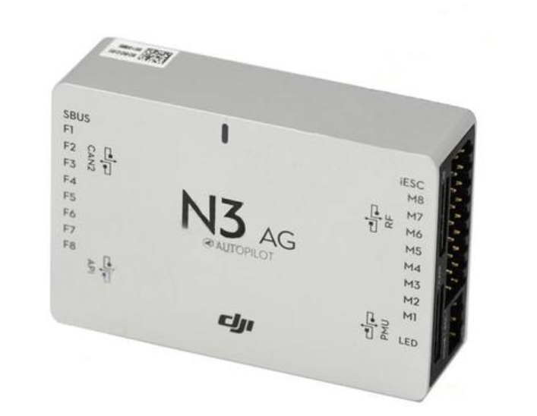
N3 flight control
The picture above shows the latest flight control system for quadcopter produced by Dajiang company and it’s price about 6000 RMB.
- Task equipment.It refers to the equipment, instruments and their subsystems that are equipped to UAV to achieve the specific mission of UAV flight.
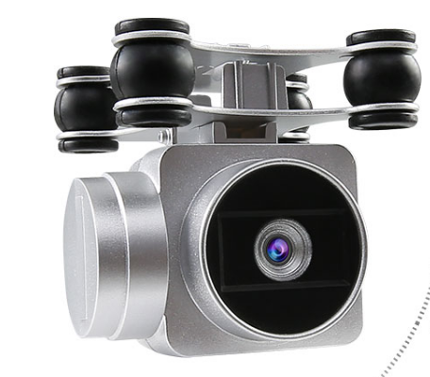

3.Connection of quadcopter

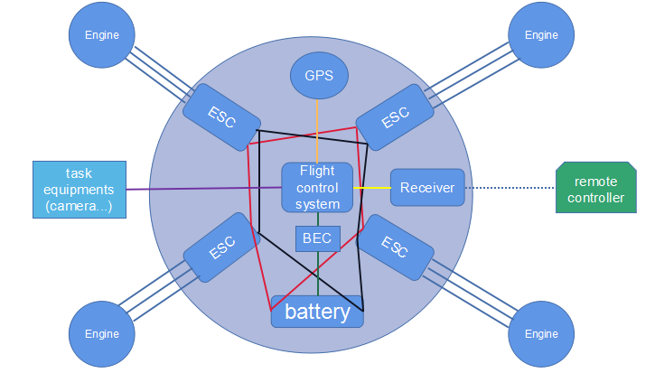

An Unmanned Aerial System (UAS) consists of three major systems; viz. the UAV, the payload and the Ground Control System (GCS). The UAV consists of the following components.
•
Airframe: This is a mechanical structure that houses all other components in the UAV. In a fixed-wing UAV, it consists of the fuselage, wings and control
structures like rudder, elevator and ailerons that provide lift and control during flight. In a multi-rotor UAV it consists of arms or booms that support electric motors, a central bay housing the battery, flight controller, sensors and electronic components. An additional structure for mounting payloads is also usually present.
•
Propulsion system: In UAVs with electric propulsion, it consists of motors, propellers, Electronic Speed Controllers (ESCs) and batteries.
•
Flight controller: This is a specialized electronic component with sensors to control and navigate the UAV autonomously. It takes data from sensors, other
electronic components and control signals from the user and runs navigation algorithms to autonomously control and navigate the UAV.
•
Navigation system: This is a logical unit, consisting of sensors like Inertial Measurement Units (IMUs), magnetometers, barometers and GPS. IMUs have
accelerometers and gyroscopes inside them. These provide the flight controller with the necessary data to control and navigate the UAV. The sensors may be physically placed inside the flight controller or outside.
•
Communication system: It consists of radio receivers on the UAV to receive control inputs from the Ground Control System (GCS) and telemetry radios to send data from the UAV back to the GCS. It may also include video
transmitters to send real-time video feeds from the UAV to the GCS.
•
Sense and avoid: These are sensors to sense and avoid obstacles during flight.
•
Payload: This may consist of one or more cameras (visual, multi-spectral, hyper-spectral) or sensors for aerial data collection. It may also be packages meant for delivery

The GCS consists of the following components.
• A flight display: This is used for system status monitoring via telemetry data received from the UAV.
•
Communication system: This is usually a radio transmitter used by the pilot to communicate with and control the UAV.
•
Data processing: A light weight, on-the-field system for displaying and processing data from the payload.

